1493 E. Livingston Avenue Columbus Ohio 43205 (614 258-4633)
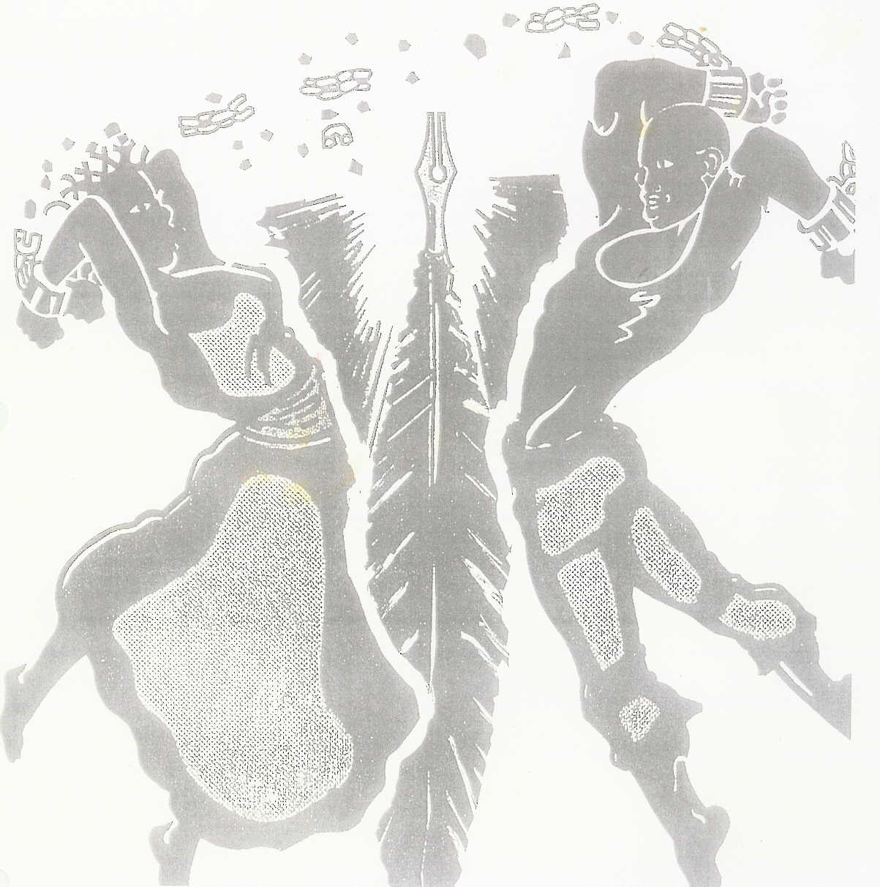
“Freedom with the stroke of a
Pen, written in a people’s blood”

2022 PERFORMANCE CONTRACT
Submit by May 15, 2022

Please Type or Print:

1. Who is your contact person? ____________________________________________

2. What is the contact person’s telephone number? ____________________________

3. Where should we send address confirmation? __________________________________________________________________

4. List stage name and performers:

Stage Name: ________________________________________________________

Performers: _________________________________________________________

5. What type of talent will you be performing? ________________________________

6. Describe equipment you will bring (includes format of prepared music, instruments, etc.)
__________________________________________________________________________________________________________________________________________

7. Please list approximate time needed for the following:

Equipment set-up __________________________

Performance time___________________________

Equipment breakdown_______________________

8. Describe any special needs: ______________________________________________________________________

****************************************************************************************************
(Internal use only)

Confirmation sent: ___________ Method: Mail/ Fax/ Telephone

Signed: _________________________________ Date: _______________________
Alkebulan, Inc. Representative

Additional Comments: ___________________________________________________

JUNETEENTH FESTIVAL 2022
PERFORMANCE CONTRACT
RULES & REGULATIONS

1. Performance will be during the Juneteenth Festival Saturday, June 11, and Sunday June 12, 2022.

2. Performers will begin entertainment promptly at designated time. Set-up and breakdown time is not included in designated performance time.

3. All performers must register in with the stage manager one hour prior to designated performance time. Failure to do so will result in the performers’ time slot being moved (if possible) or the performers’ performance being cancelled.

4. Audio equipment, speakers, and microphones will be available to performers. The performer along with needed technicians must provide additional equipment.

5. Neither Juneteenth Festival, its sponsors, nor the City of Columbus will be responsible for loss or damage to personal property belonging to, or in the care of the performer.

I have read, understand, and agree to the rules and regulations listed above.

Performer Stage Name: __________________________________________________

Applicant’s Signature: __________________________________ Date: ___________

The Juneteenth Festival intends it videotape the festival for promotional purposes related to the festival. This may include your performance. If the festival is permitted it videotape your performance for this purpose, please initial here. _____________

Signed: ________________________________________ Date: _________________
JuneteenthOhio Authorized Official

